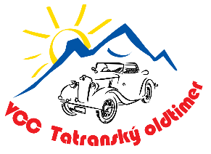
APPLICATION

Tatranský Oldtimer 04.07. – 06.07.2025 (Friday – Sunday)

Name and surname:

Address, state:

Fellow passengers:
Email: | @ |  | Phone №:

Oldtimer
Factory mark: |  | Year of manufacture:
Engine content: |  | № of cylinders:

ACCOMMODATION RESERVATION

HOTEL SOREA URÁN***
Date of arrival: |  |  | Date of departure: |  |  |  | № of nights:
№ of adults: |  |  |  | № of children < 15years:
Note:

I request invoicing of accommodation for the company:

Company name:
Address, state:
VAT №: |  | ID №:

The event will take place in the peak season and the capacity of the hotel is limited. We therefore ask for an early reservation. The invoice for the accommodation will be sent to you after your application has been confirmed by the organizing committee, and your participation in the meeting will be confirmed after its payment. I am aware that I participate voluntarily at my own risk and in case of damage to myself, my crew members or the vehicle, I will not claim compensation from the organizers.

Date: |  | Signature:

Send applications by email: tatranskyoldtimer@gmail.com

